**Problem Solution**

An approach was selected for a discrete solution based on offline road geometry generation. Focused on its minimum data transmission.

A set of unit vectors known as Normal-Tangential (N-T) Coordinates is used for the formulation of this path. N-T coordinates have been used extensively in works that define curvilinear motion of particles in space [11]. For this project, a 2D Euclidean space is selected in which N-T coordinates will be used to represent the motion of vehicle’s center of mass traversing a curve as shown in Figure 2.

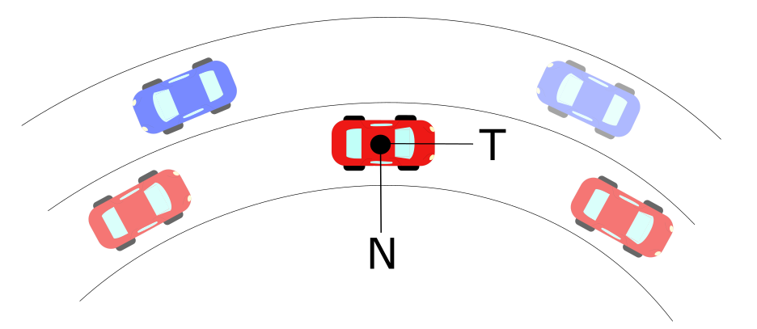

Figure 2 - Normal-Tangential Coordinates Example in Vehicle’s Center of Mass

As the vehicle goes through the curve, it is limited to constraints provided by road geometry and friction limits on the vehicle tires [12] [13]. These limits are related to the acceleration a vehicle goes under circular motion, which is denoted as:

Where:

a = Total Acceleration of Vehicle (m/s2)

v = Tangential Velocity of Vehicle (m/s)

= Curvature at an Instantaneous Point (m-1)

N =Normal Unit Vector

T= Tangential Unit Vector

Curvature can be defined analytically, physically and geometrically. It measures how fast the tangential unit vector T changes with respect to an instantaneous point in the curve. The inverse of curvature is known as radius of curvature which indicates the radius of circumscribed circle at a point in a curve. Derivations for defining curvature are given in the Appendix [A.1], and have been extensively developed in other works [11] [12]. Curvature can be expressed in a vector form that has a direction in the Normal Unit Vector shown in Figure 2 . By definition of N-T coordinates, a vector perpendicular to the curvature direction will provide a velocity tangent vector approximation. This velocity vector provides a heading angle to the desired trajectory that is needed to follow a road path.

Typical highway roads are designed based on AASHTO guidelines to provide a natural, easy-to-follow path for drivers, such that the lateral force increases and decreases gradually as the vehicle enters and leaves a circular curve [16]. This leads to an approach of curvature generation based on AASHTO road geometry to obtain heading angles. To develop this, a geometric definition of radius of curvature is used to obtain both its magnitude and direction as shown in the Appendix [A.2] [17]. The radius of curvature is computed from discrete points that represent coordinates of a road. To obtain different approximations, different methods to coordinates were used. The first method involved a base model of the road based on AASHTO guidelines. The second method involved using Google Earth coordinates, and the third one involved GPS coordinate acquisitions.

Appendix

A.1 – *Heading Angle Integration Formulation*

The arc-length s of a curve is defined as the length traveled by a certain amount of degrees along a constant radius r. If s is sufficiently small, a triangle can be formed in between these three parameters, which are related through geometry:

Defining r as the radius of curvature at the specific arc-length and letting.

By the previous assumption of small angles:

Which leads to

(1)

Let the Curvature be denoted as

Substituting this definition into equation (1)

Assuming a differential section for and. Rearranging for:

By separation of variables and integration

Which concludes that the angle of orientation as a function of arc-length s can be found through numerical integration of the curvature as:

To obtain the curvature, let a scalene triangle with corners A, B, C have a circumscribed circle of radius r.

A.2 – *Discrete Curvature Formulation*

Let a scalene triangle with corners A, B, C have a circumscribed circle of radius R in Euclidean 2D space as shown in Figure.

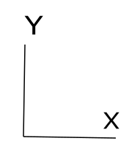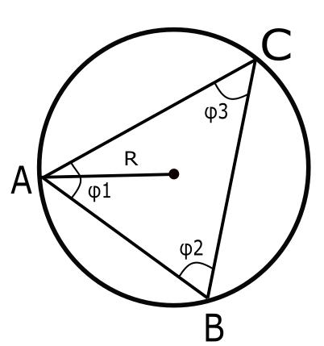

Circumscribed Circle in Scalene Triangle

If we let a vector D be the cross product in between the vectors AB and AC, the direction will be pointing out normal to the plane defined by the intersection of AB and AC. By definition of the magnitude for cross product:

Let a vector E be the cross product of D with the vector AB, defining this new vector in the direction of as shown in Figure. Let the magnitude of vector E be defined as:

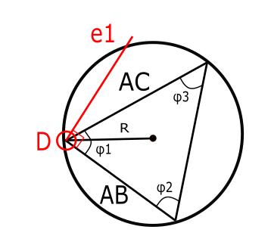

Similarly, let a vector F be the cross product of D with the vector AC, defining this new vector in the direction of. Let the magnitude of vector E be defined as:

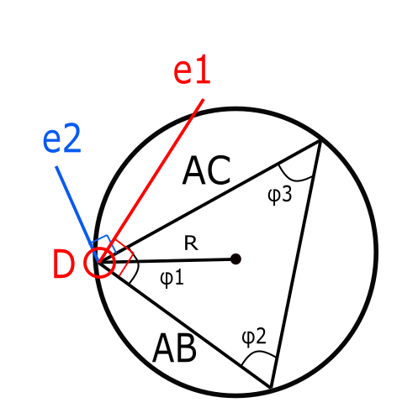

The unit vectors of and are defined by the following:

By definition, the midsection of any triangle’s side intersects with each other at a point P as shown in Figure. These intersecting lines denote two triangles with the same angle in between the unit vectors and their corresponding midsections as shown below.

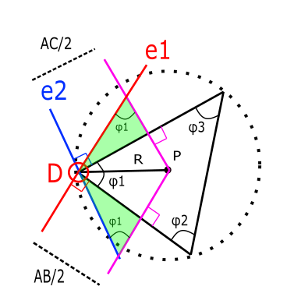

From these triangles, it is possible to break the vector DP into components along unit vectors and to obtain a new definition of DP in a different set of coordinates as follows:

From our previous definition of the vector D, it is possible to simplify further:

With these components, it is possible to obtain the magnitude as follows:

Using previous definitions of E and F:

Using previous definition of D, it is possible to obtain the radius of the prescribed circle in terms of only the difference in between points A, B and C.

Using the previous definition, it is possible to apply the formulation of R to differentially small arc segments as it is shown below.

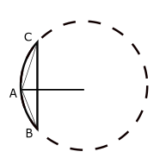

Scalene Triangle in Arc-Segment

By definition, the radius of this circumscribed circle is called radius of curvature, and its inverse is known as curvature denoted as:

Through this definition it is possible to extend the application of this discrete radius of curvature and applying it to long-discrete arc segments as shown in Figure:

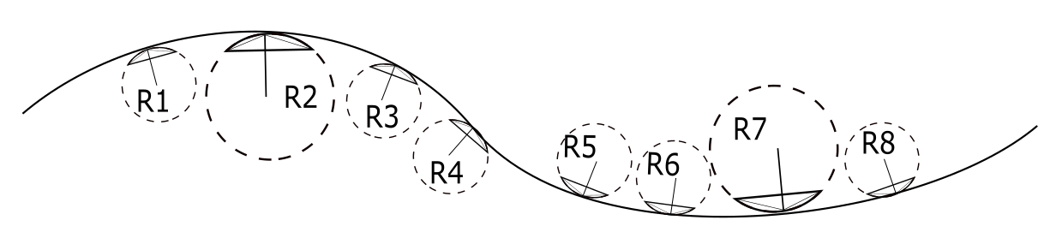

Road Section with Discrete Sections